**Oracle Client Installation for ERDM Connectivity.**

1. Team to install the ODAC 32-bit driver compatible with Oracle 19 c version. (ODAC19.21Xcopy_x86.zip)
   1. Create a folder in C drive **C:\oracle** and provide all the permissions required.
   2. Execute the below command in the command window from the path where the ODAC 32-bit driver is unzipped.

**install.bat all c:\oracle odac**

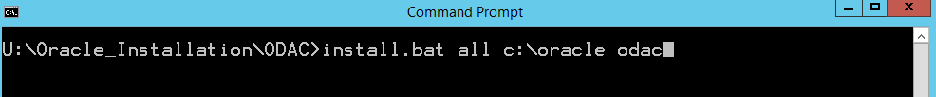

1. Team to install the Oracle 19c 32-bit client software. ( WINDOWS.X64_193000_client)

Please follow the instructions for the Oracle Client installation.

* 1. Choose the Administrator option.

* 1. Choose the default ‘Use Windows Built-in Account’.

* 1. Provide the path for the software installation.

* 1. Click on Install button.

* 1. Click on Close button.

* 1. Check the Environment variables to see if both Oracle client and ODAC folder path is added.

* 1. Copy the tnsnames.ora file to ‘E:\Oracle_19c_Client\product\19.0.0\client_1\network\admin’ (Oracle Client Folder) and ‘C:\oracle\network\admin’ (ODAC Folder).

* 1. Open a Command prompt and enter the tnsping to the Service Name to connect and check if the connection is established.

